https://github.com/aiiisana/go2024/tree/main/lab2

**Exercise 1: Connecting to PostgreSQL Directly with database/sql**

**Objective:** Connect to a PostgreSQL database, create a table, insert some records, and query them.

1. **Setup PostgreSQL Connection:** Create a Go program that connects to your PostgreSQL database using the pq driver.

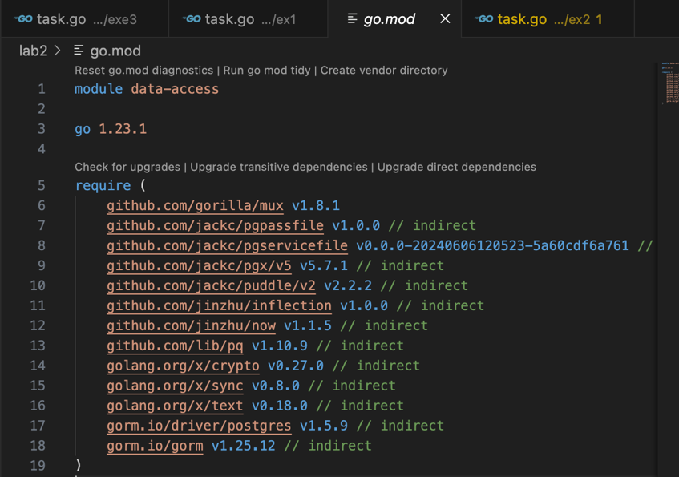

1. **Create a Table:** Write a function to create a simple table users with columns for id, name, and age.

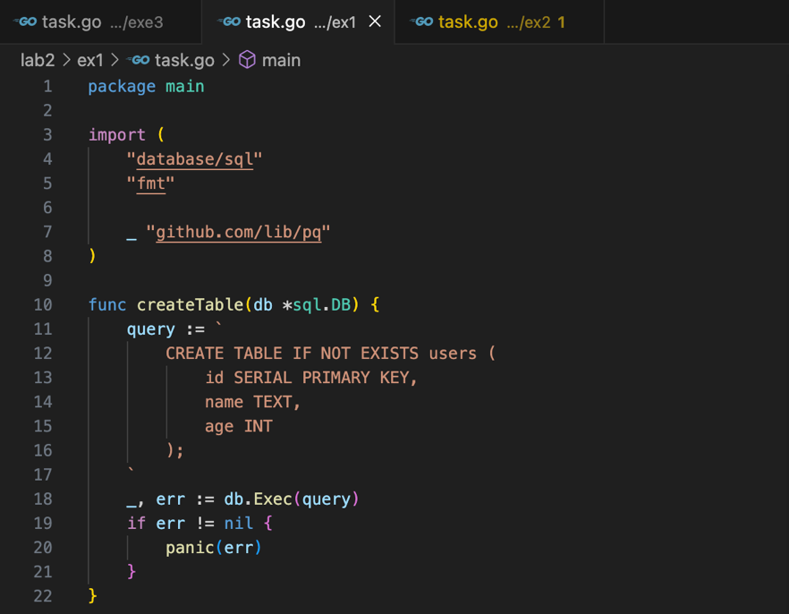

3. **Insert Data:** Write a function to insert data into the users table.

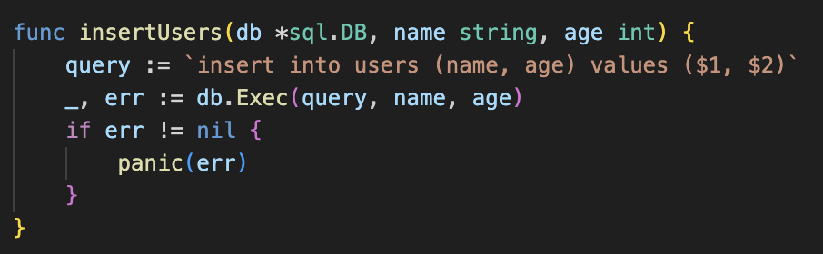

4. **Query Data:** Write a function to query and print all users.

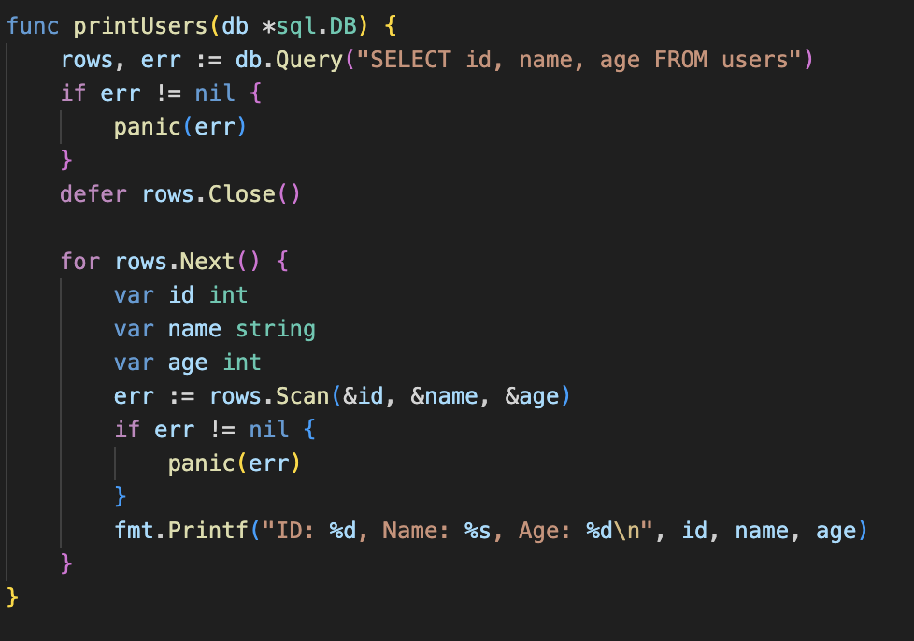

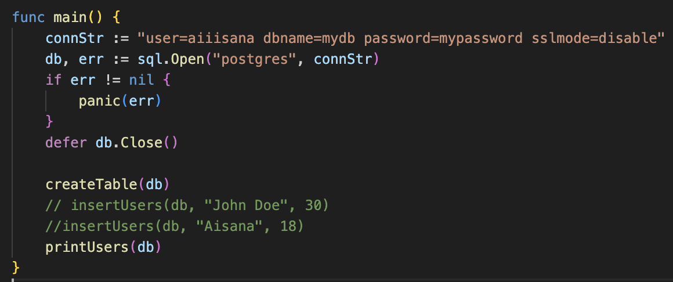

Output:

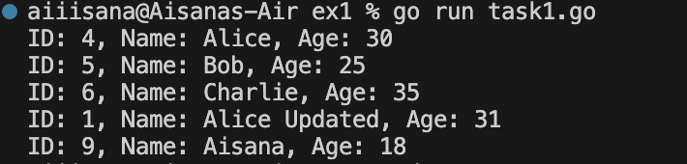

**Exercise 2: Working with PostgreSQL using GORM**

**Objective:** Use GORM to perform similar operations as above, but with an ORM approach.

1. **Setup GORM:** Install GORM and the PostgreSQL driver:



1. **Create a Model:** Define the User model that maps to the users table.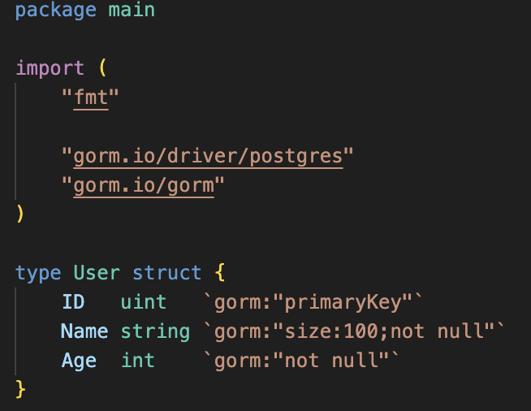
2. **Auto Migrate:** Use GORM’s AutoMigrate to create the users table based on the User struct.

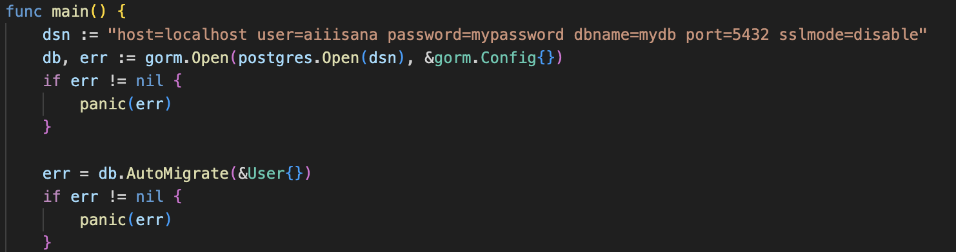

1. **Insert Data:** Use GORM to insert users into the database.



1. **Query Data:** Use GORM to retrieve users from the database.

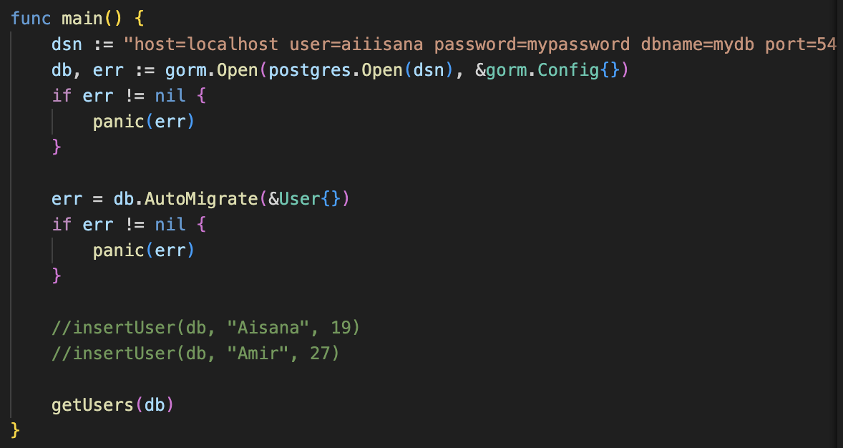

Output data:

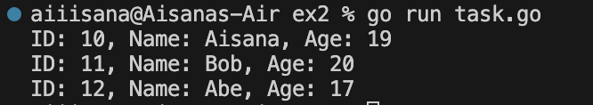

**Exercise 3: Rest API (make for both direct queries to database and gorm)**

**Initialization for both direct query and GORM**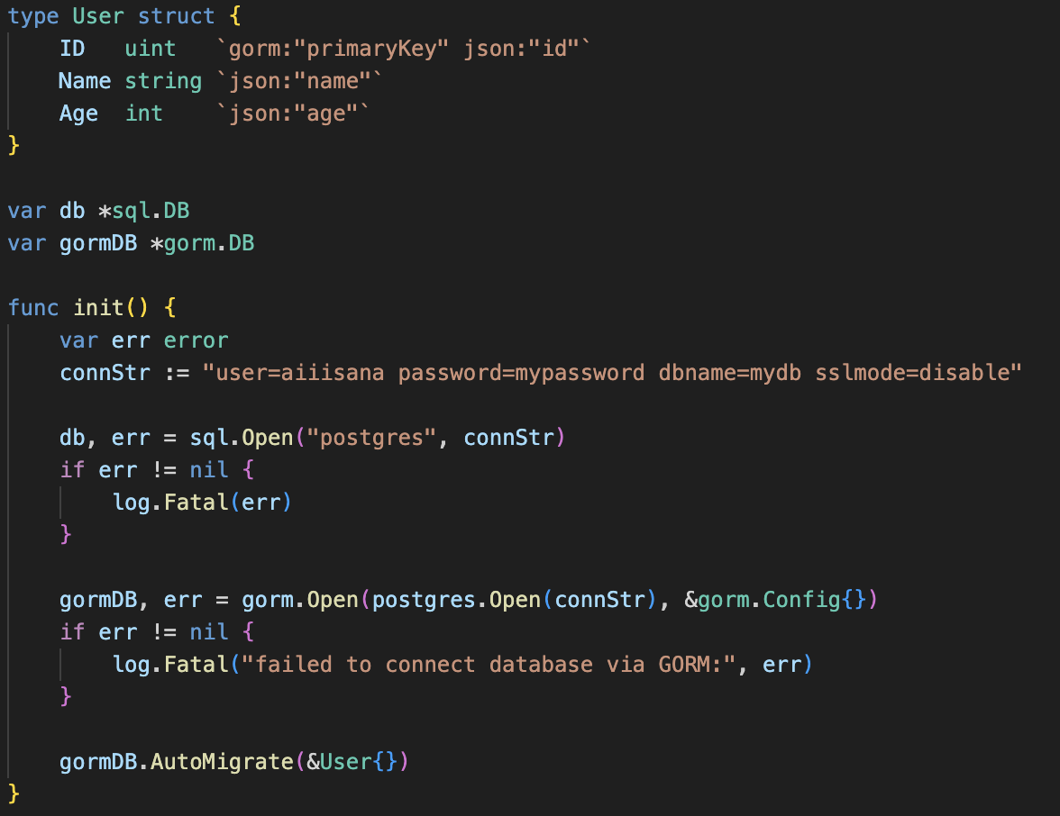

Create a REST API with routes for GET, POST, PUT, and DELETE.

**Get Users (GET /users):** A handler to fetch all users from the users table.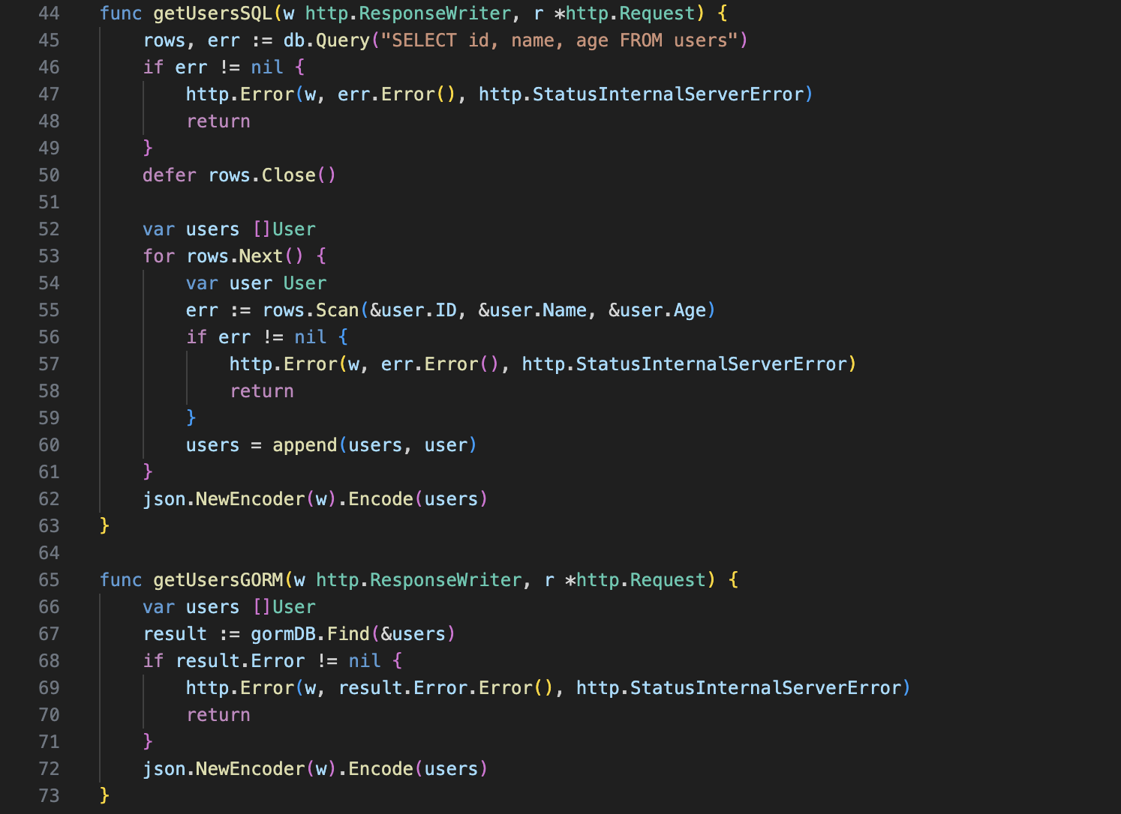

**Create User (POST /user):** A handler to insert a new user into the users table.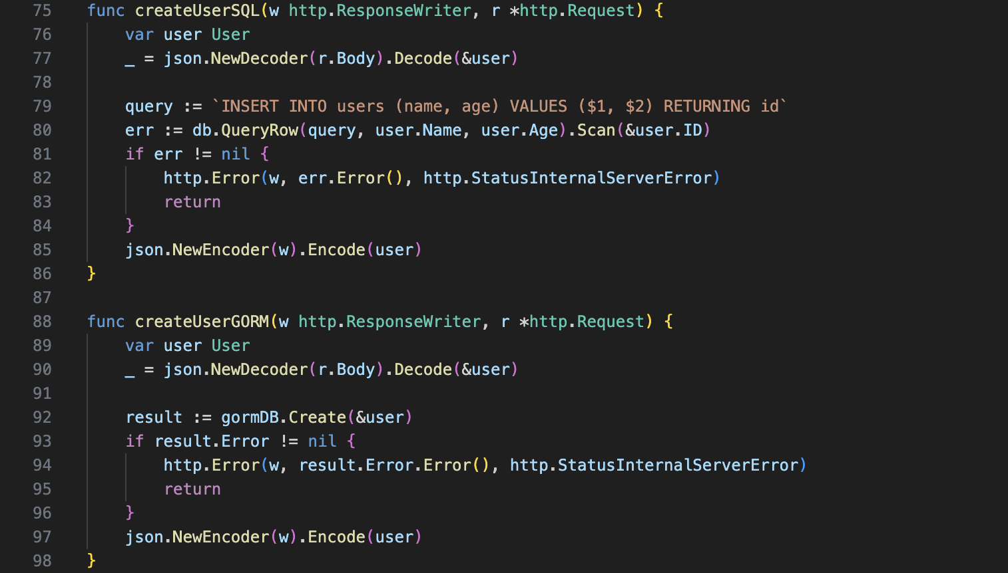

**Update User (PUT /user/{id}):** A handler to update an existing user in the users table.

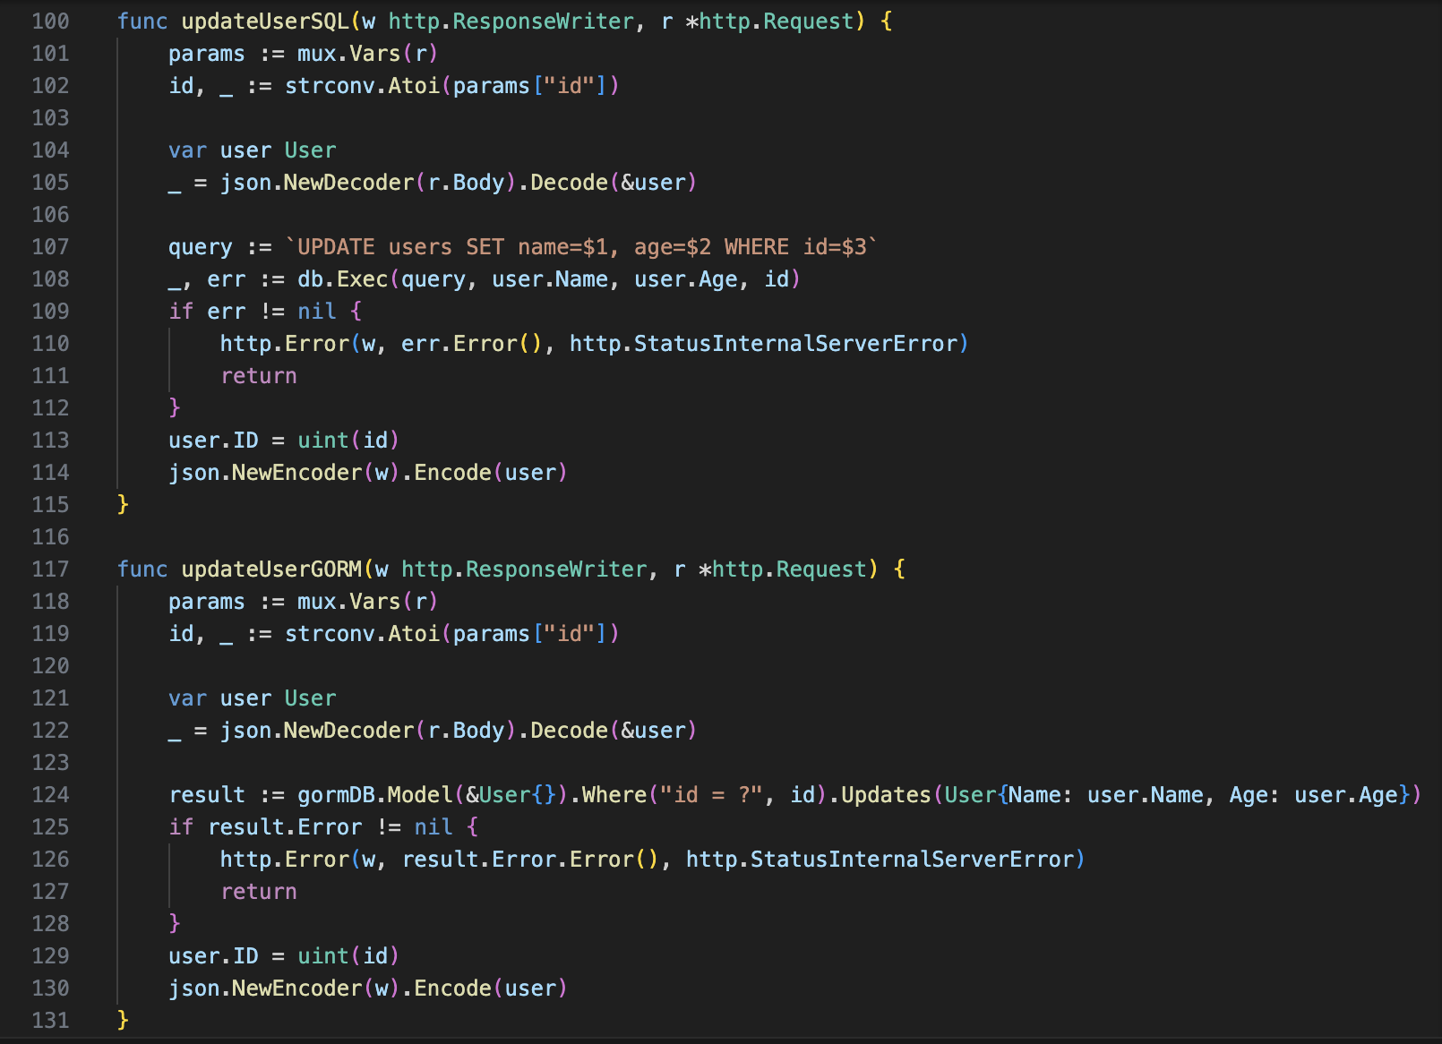

**Delete User (DELETE /user/{id}):** A handler to delete a user from the users table.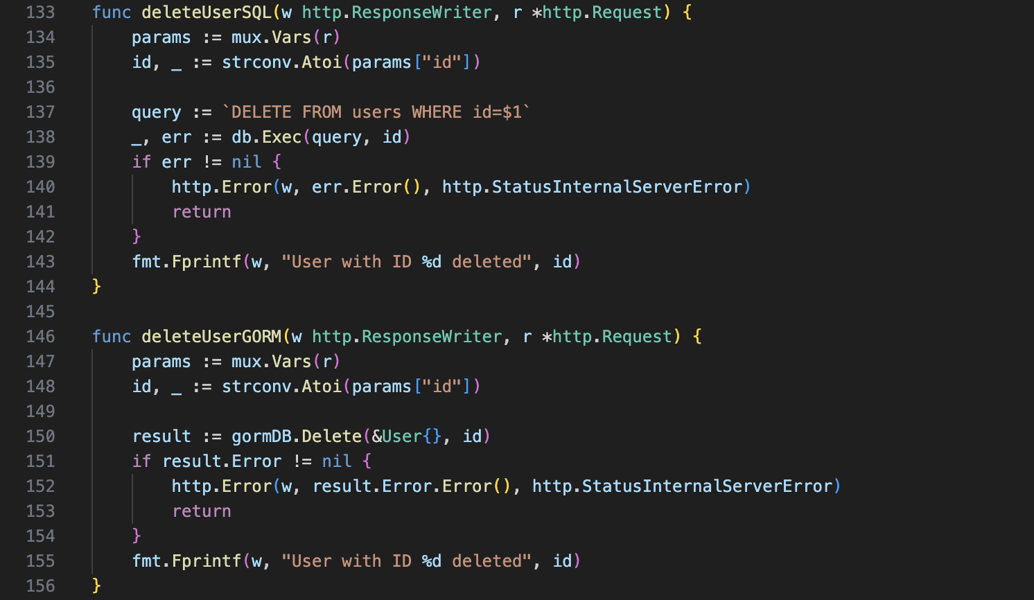

Setted up router links and started programm:

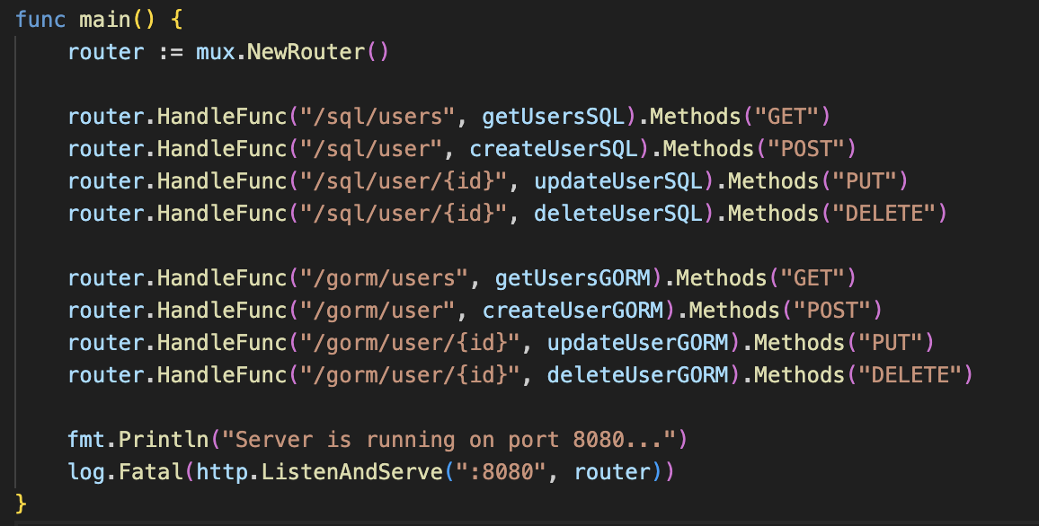

Running program:



Output:

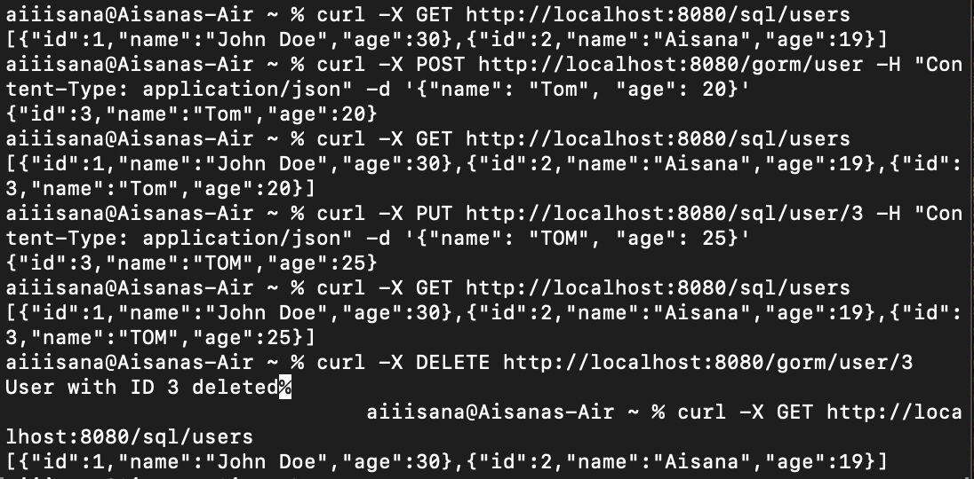

**Exercise 1: Advanced PostgreSQL Operations with database/sql**

**Objective:** Connect to PostgreSQL, perform advanced operations, and handle transactions and error management.

1. **Setup PostgreSQL Connection:**
   * Create a Go program that connects to your PostgreSQL database using the pq driver.
   * Implement connection pooling with sql.DB.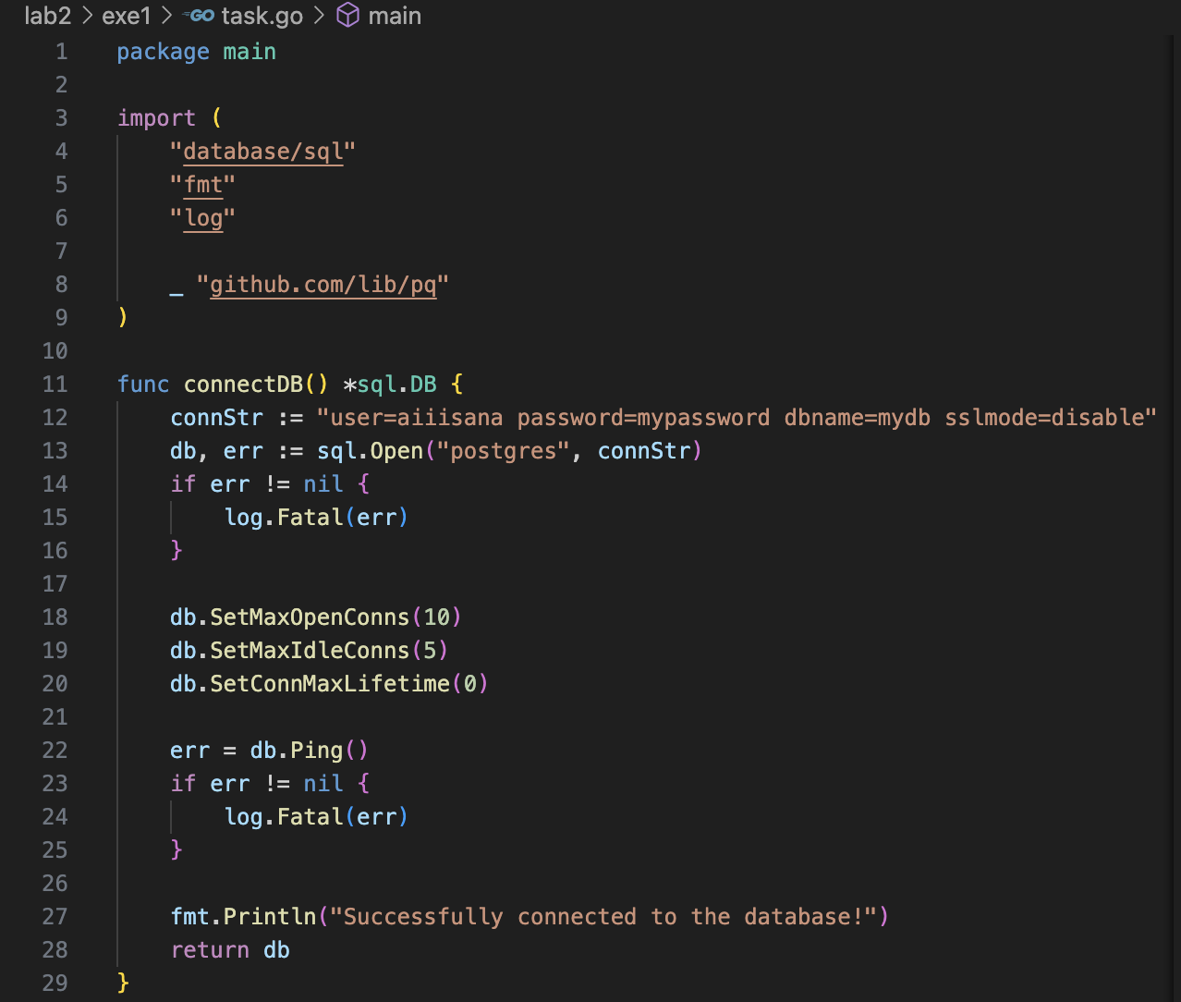
2. **Create a Table with Constraints:**
   * Write a function to create a users table with the following constraints:
     + id as a primary key, auto-incremented.
     + name as a unique, non-null field.
     + age as a non-null integer field.

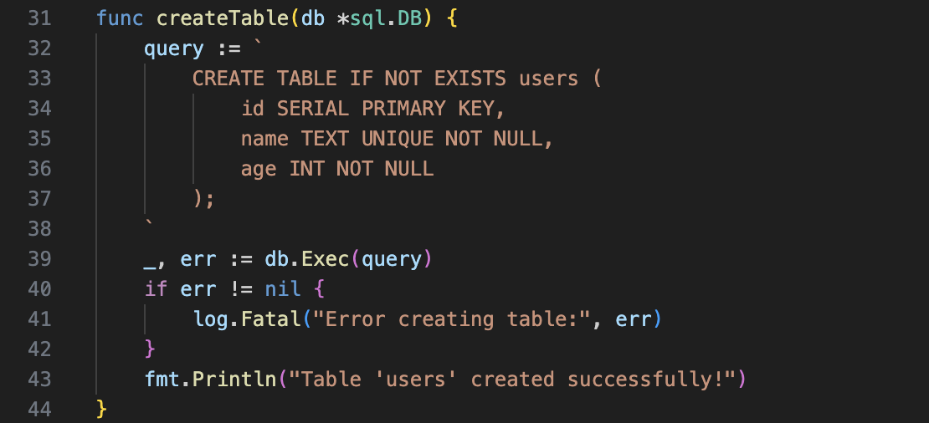

1. **Insert Data with Transactions:**
   * Write a function to insert multiple users into the users table within a transaction.
   * Implement error handling to roll back the transaction if any error occurs during insertion.

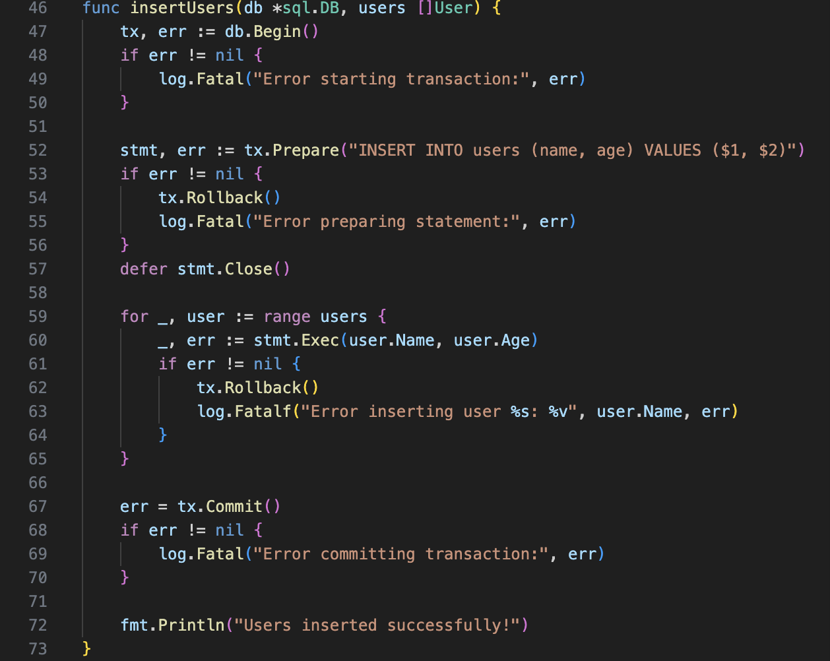

1. **Query Data with Filtering and Pagination:**
   * Write a function to query and print users with optional filters for age and pagination support.
   * Implement pagination to return a specific number of results per page.

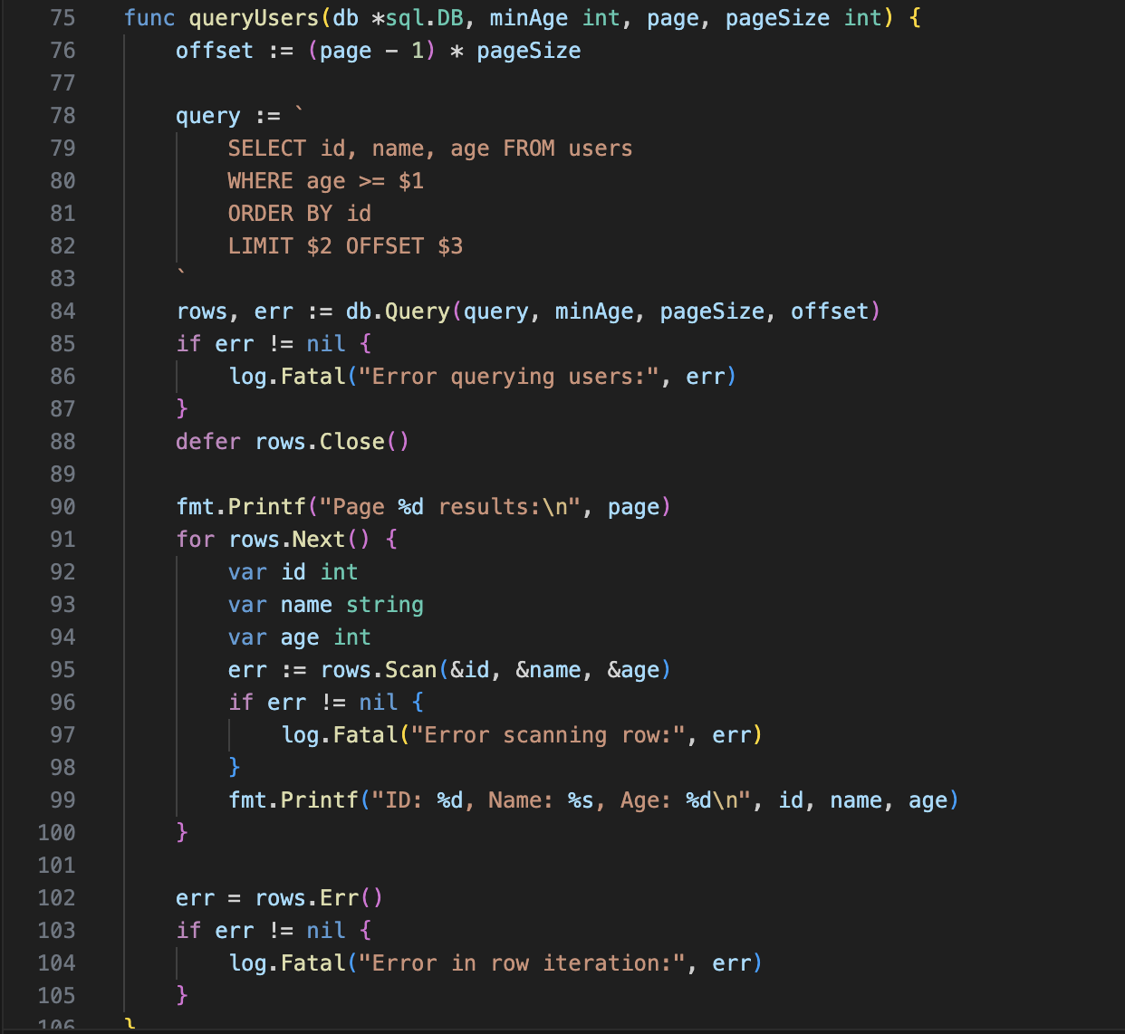

1. **Update and Delete Data:**
   * Write functions to update a user’s details and delete a user by their ID, including error handling.

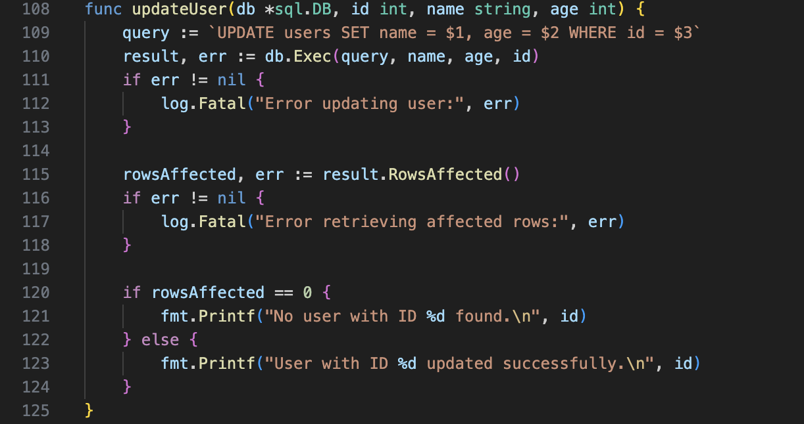

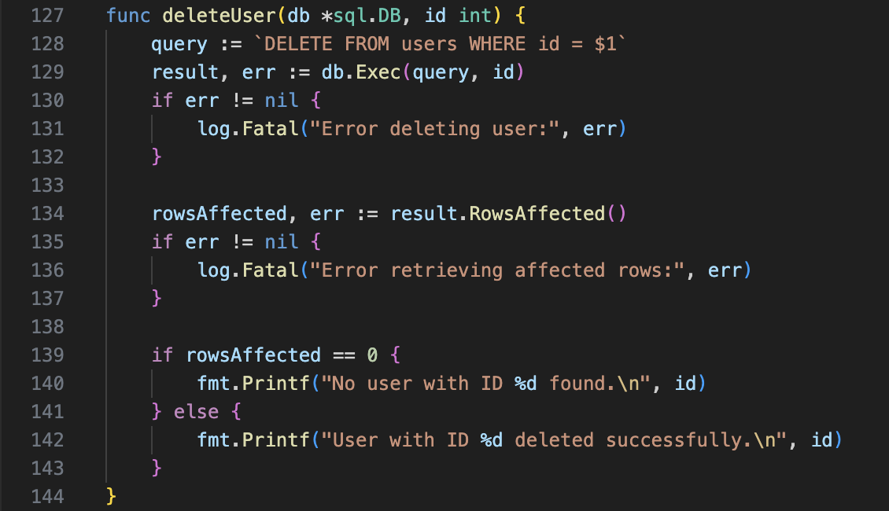

Created struct for convience and array of users, started the program

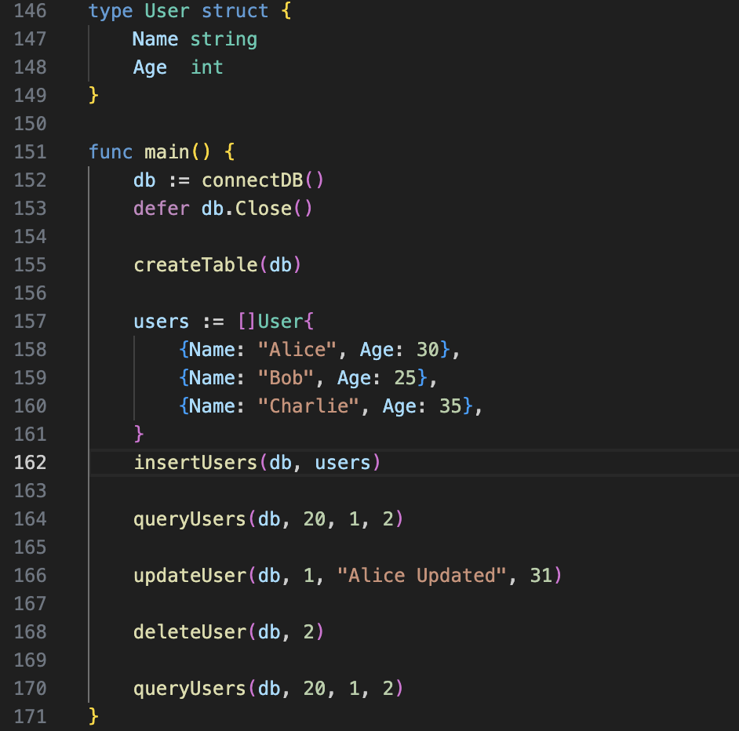

Output:

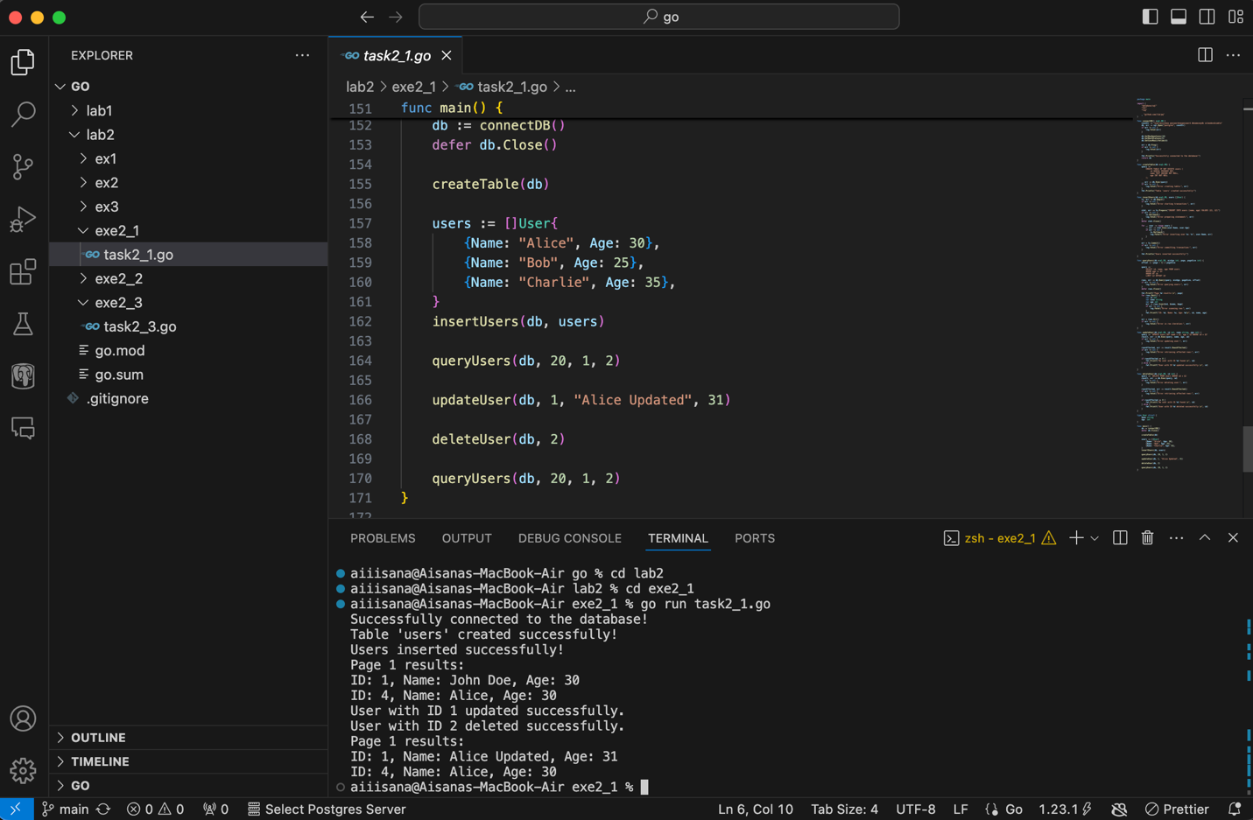

**Exercise 2: Advanced GORM Operations**

**Objective:** Utilize GORM for more advanced operations including transactions, associations, and validation.

1. **Setup GORM with PostgreSQL:**
   * Install GORM and the PostgreSQL driver.
   * 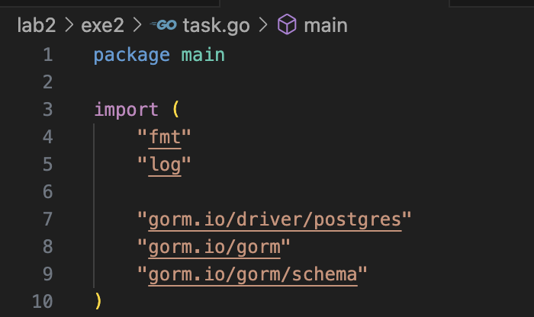Configure GORM with connection pooling.

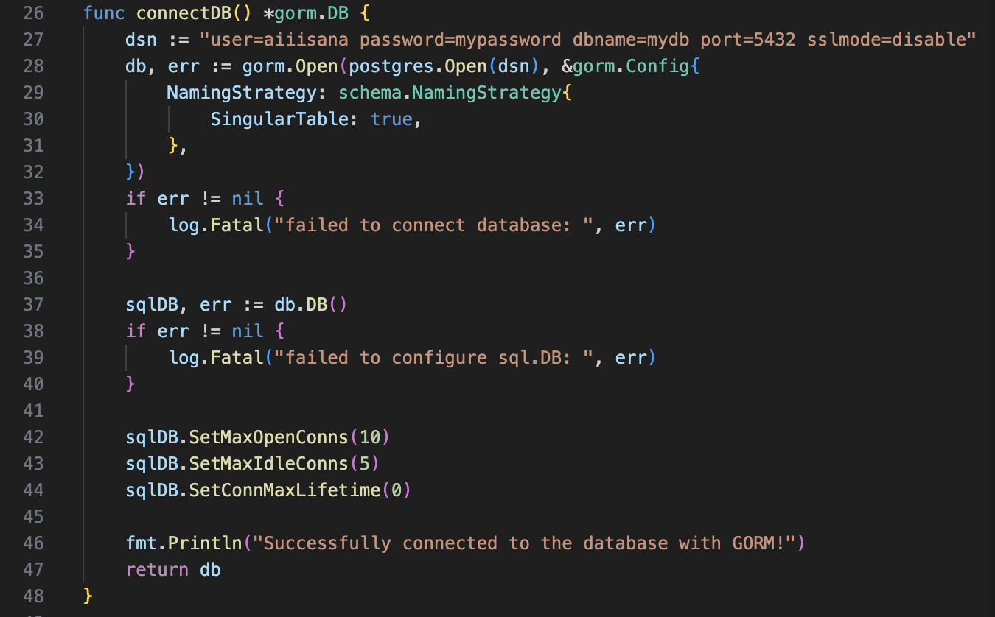

1. **Create a Model with Associations:**
   * Define a User model with fields and add an associated Profile model. For example:
     + User with fields: ID, Name, Age.
     + Profile with fields: ID, UserID, Bio, ProfilePictureURL.
   * Set up the one-to-one association between User and Profile.

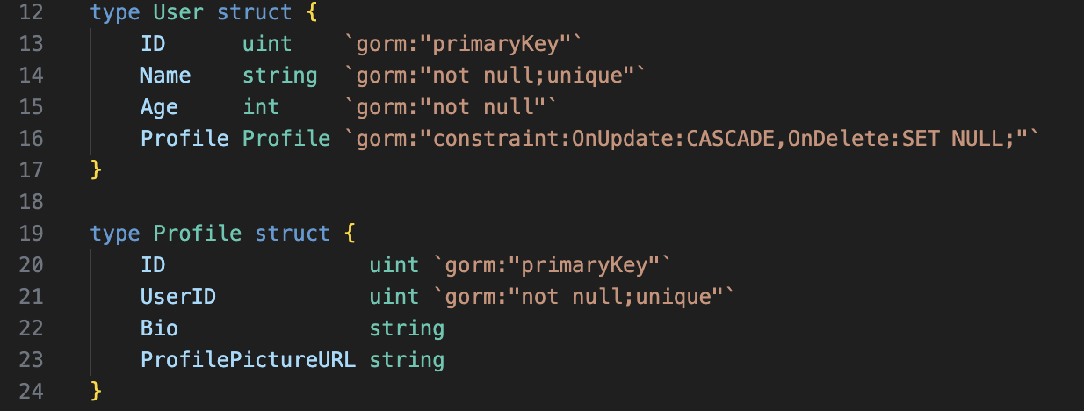

1. **Auto Migrate with Constraints and Associations:**
   * Use GORM’s AutoMigrate to create tables for User and Profile with appropriate constraints and associations.

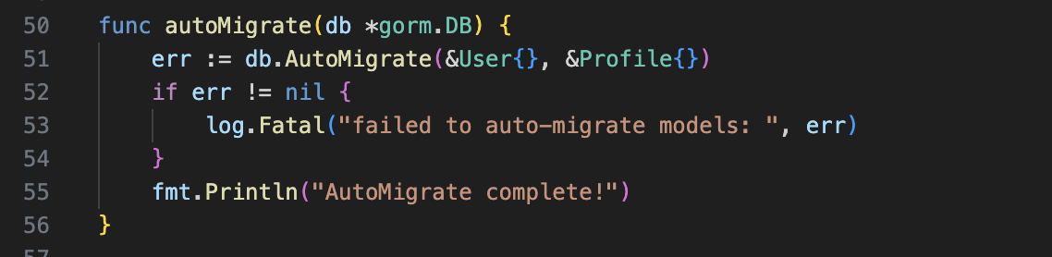

1. **Insert Data with Associations:**
   * Use GORM to insert a User and an associated Profile in a single transaction.

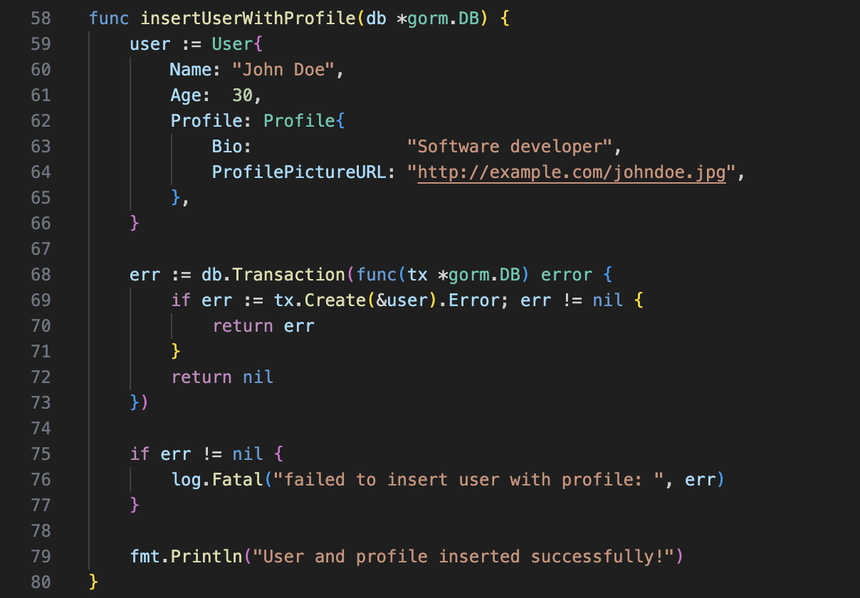

1. **Query Data with Associations:**
   * Use GORM to retrieve users along with their profiles. Implement eager loading to optimize queries.

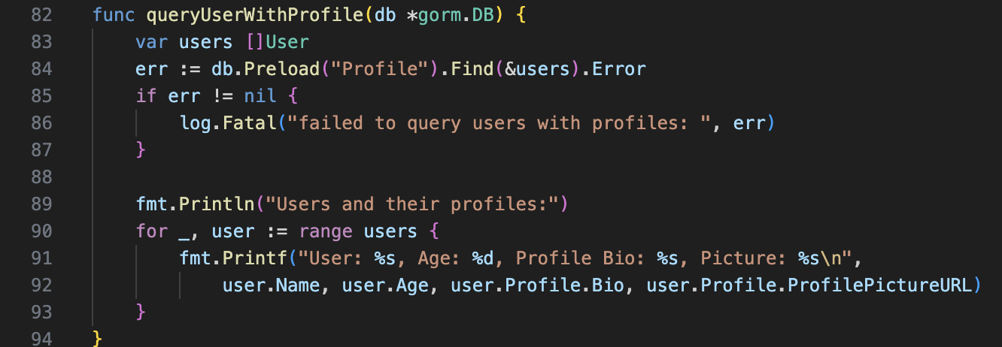

1. **Update and Delete Data:**
   * Write functions to update a user’s profile and delete a user with associated profile, ensuring referential integrity.

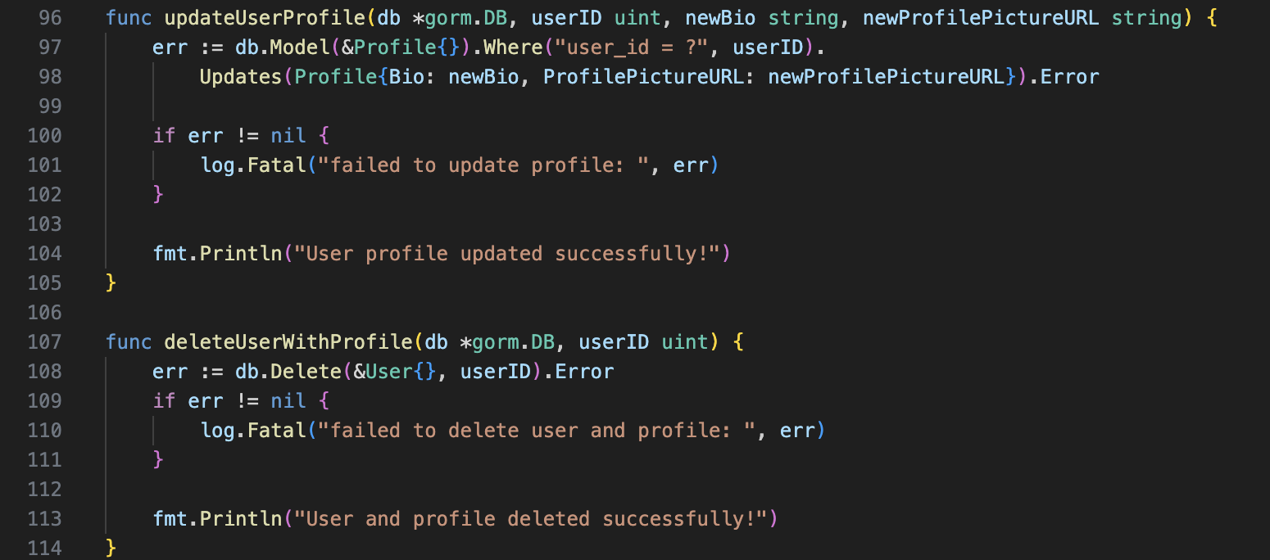

Output:

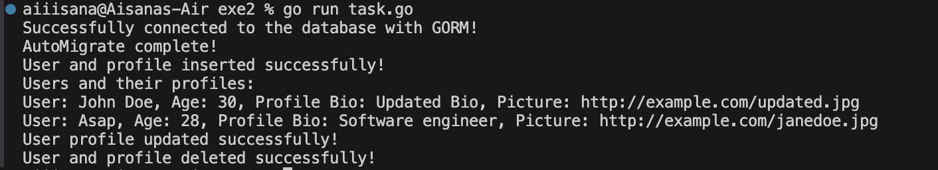**Exercise 3: REST API with Advanced Features**

**Objective:** Create a REST API with both direct database/sql queries and GORM, including additional features like filtering and sorting.

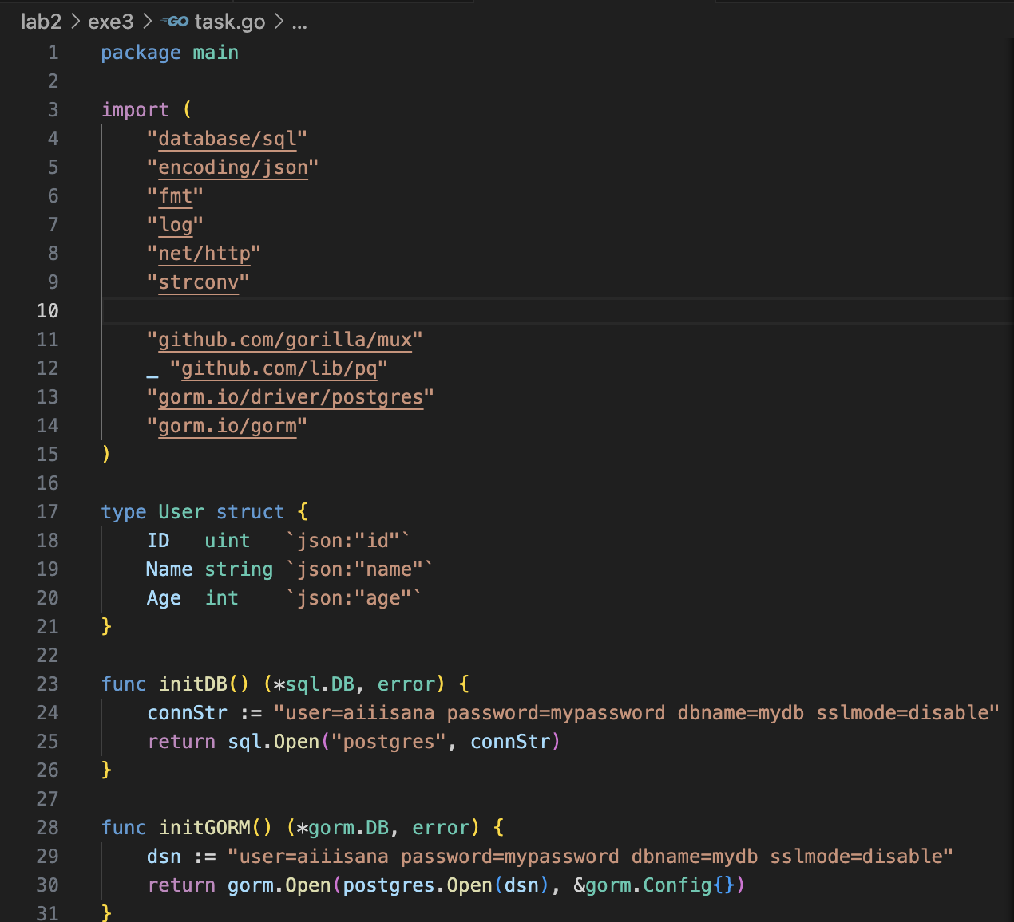

1. **Create REST API Routes with Direct SQL Queries:**
   * **Get Users (GET /users):** Fetch all users with optional query parameters for filtering by age and sorting by name.

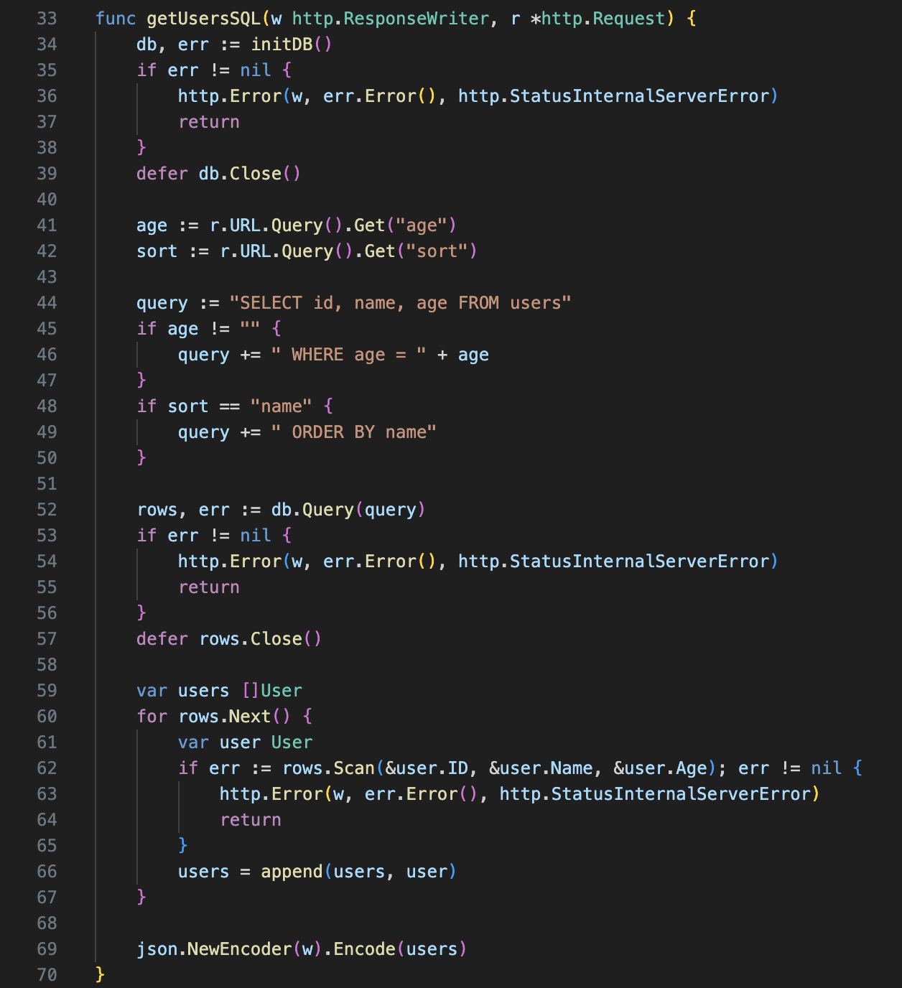

* + **Create User (POST /users):** Insert a new user with validation to ensure name is unique.

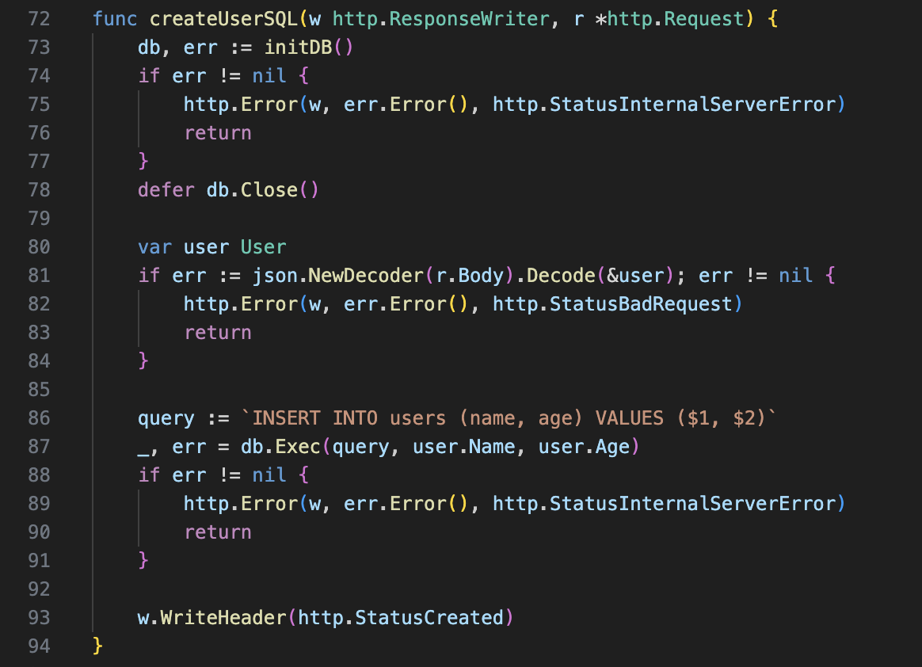

* + **Update User (PUT /users/{id}):** Update an existing user by ID with validation for name uniqueness.

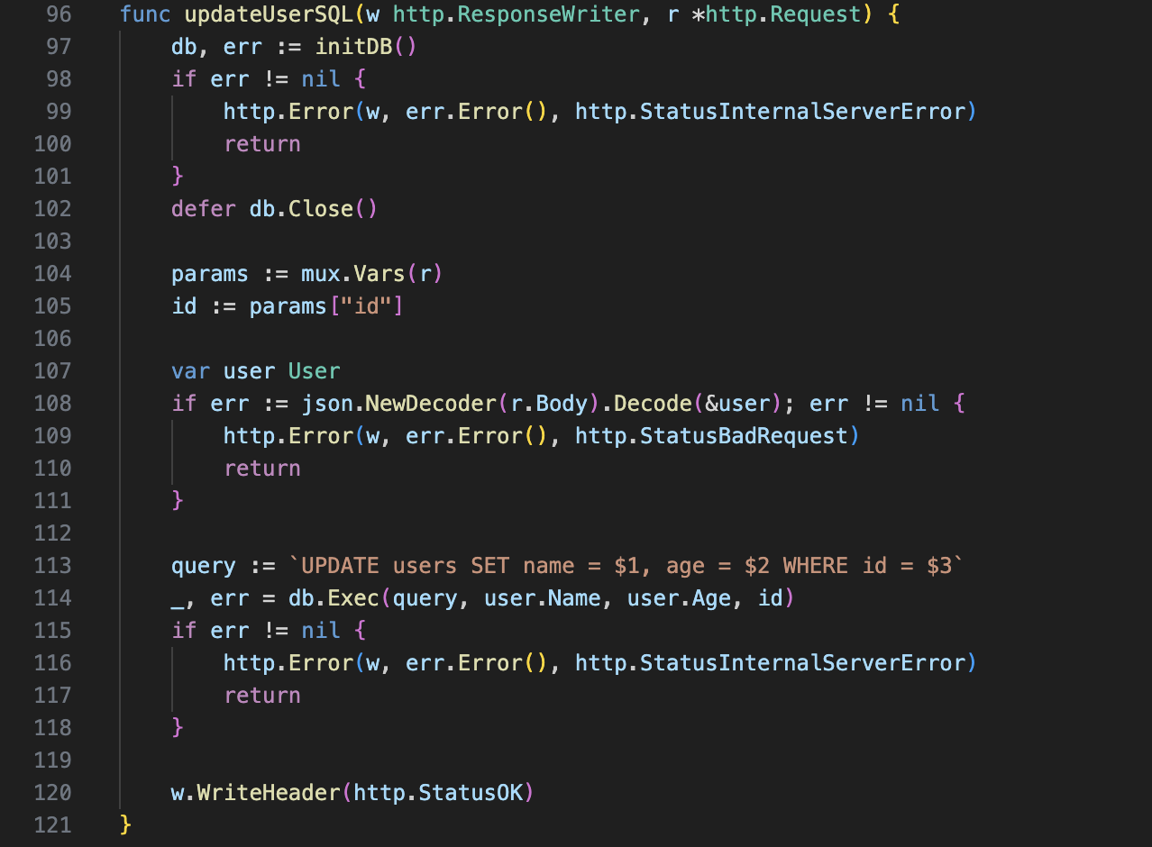

* + **Delete User (DELETE /users/{id}):** Delete a user by ID, ensuring the ID exists.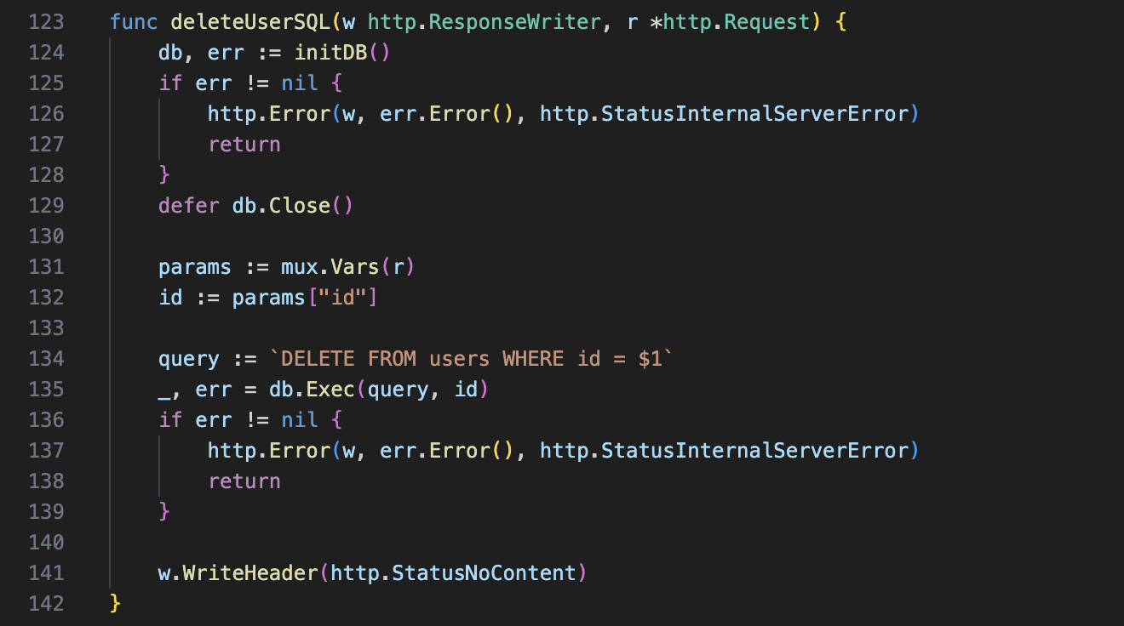

1. **Create REST API Routes with GORM:**
   * **Get Users (GET /users):** Use GORM to fetch all users with filtering and sorting options.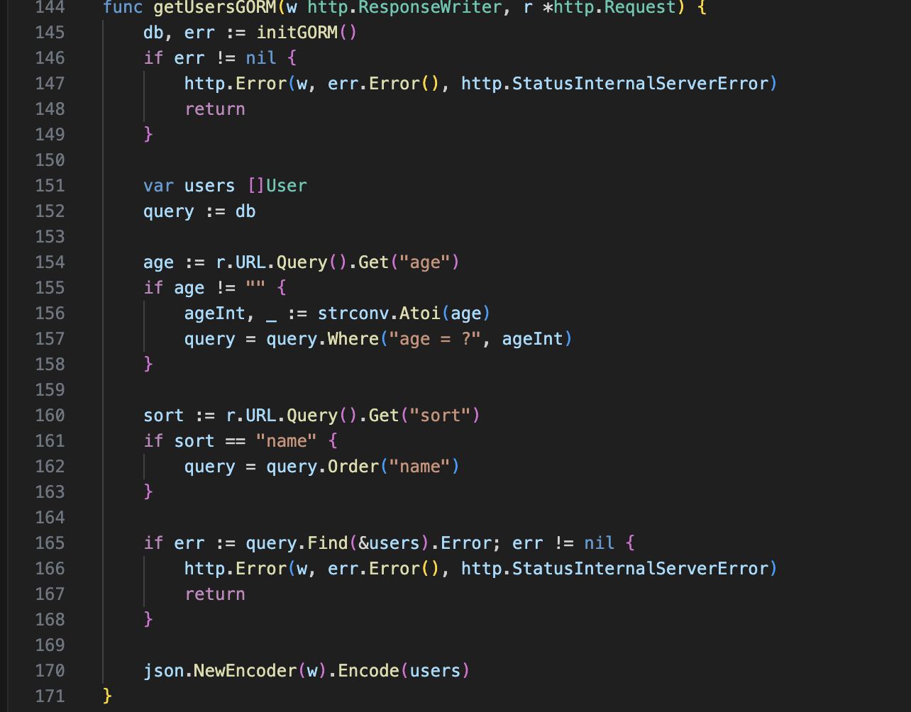
   * **Create User (POST /users):** Use GORM to insert a new user with validation.

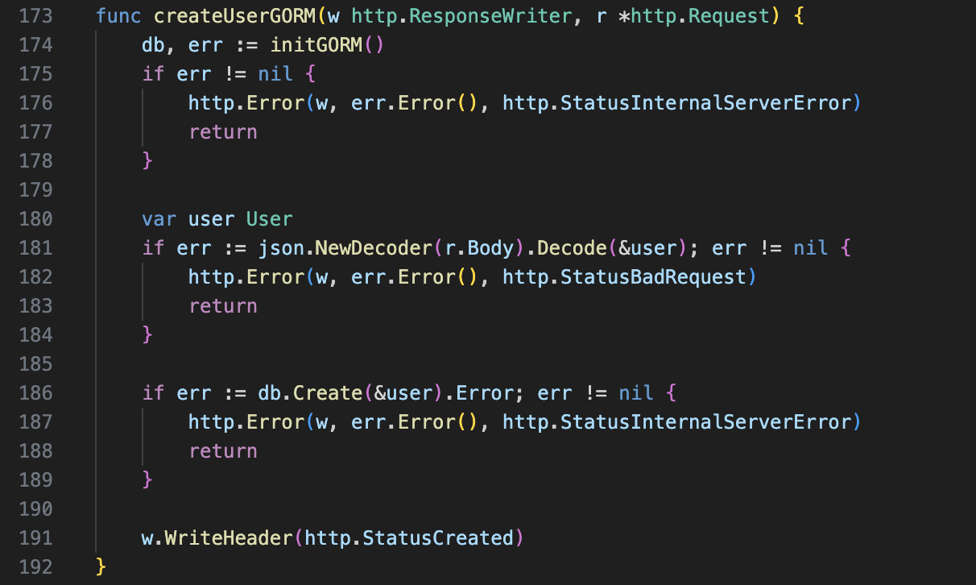

* + **Update User (PUT /users/{id}):** Use GORM to update an existing user by ID.

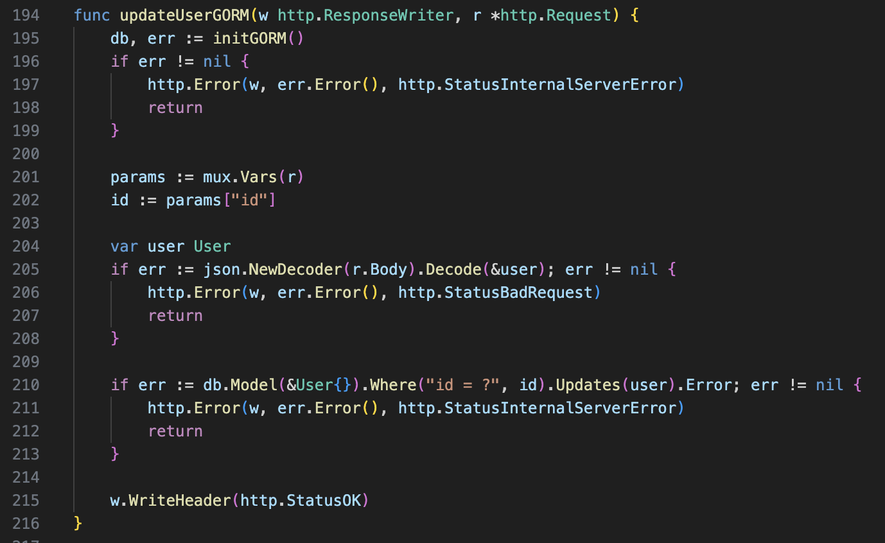

* + **Delete User (DELETE /users/{id}):** Use GORM to delete a user by ID.

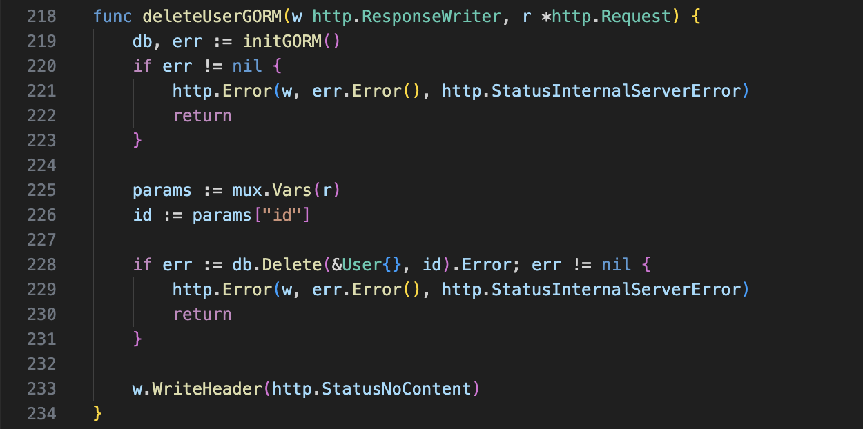

1. **Add Pagination and Error Handling:**
   * Implement pagination for the GET /users route for both direct SQL and GORM approaches.
   * Add comprehensive error handling for all API endpoints, including validation errors and database errors.

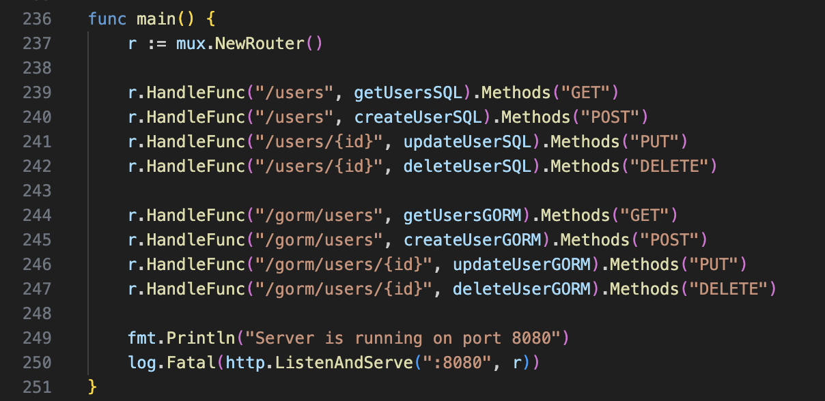

1. **Testing and Documentation:**
   * Write unit tests for each API endpoint.
   * Document the API using Swagger or another API documentation tool.

